BTEC Level 1 Introductory Certificate in Health and Social Care
Head of Department/Faculty: Miss H Pritchard
Email: H.Pritchard@barnwell.herts.sch.uk

Why study BTEC Level 1 Introductory Certificate in Health and Social Care

The Pearson BTEC Level 1 Introductory Award, Certificate and Diploma in Health and Social Care
are designed around practical skills and tasks that place an emphasis on learners demonstrating
what they can do rather than what they know in theory. The qualifications give learners the
opportunity to acquire and develop generic, transferable and sector-specific skills in order to
complete tasks and demonstrate a level of achievement that enables them to progress to further
learning.

What does the course involve?

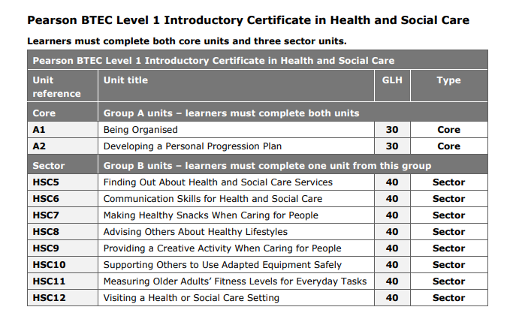

How will I be assessed?
All units are coursework based and internally assessed.

What are my progression routes?
If students achieve an overall pass grade in the BTEC Introductory Certificate in Health and Social Care, it may be possible for students to progress in an area of health and social care employment and follow an apprenticeship. If you have good levels of literacy and numeracy you may be able to study this subject at Level 2.

