Barnwell School

SMSC Policy

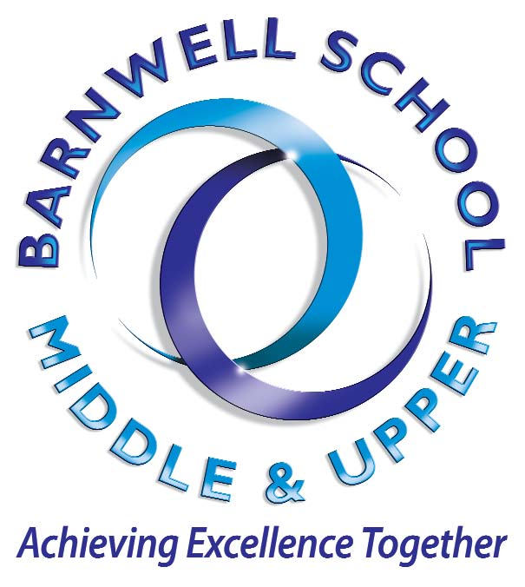

Lead SMSC Staff: | Martyn Patching
Updated on: | June 2020
To be reviewed: | June 2021

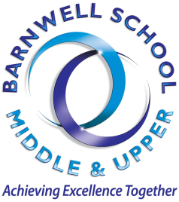
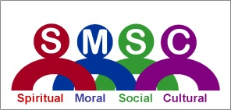

Policy for Spiritual, Moral, Social and Cultural Values (SMSC)

SMSC and the Development of Fundamental British Values

The personal development of students (SMSC) is a major aim of education and is central to the education of the whole child. It is a statutory requirement that clear and planned provision is made for SMSC for all students. The National Curriculum 2000 states that: "The school curriculum should aim to promote pupils' spiritual, moral, social and cultural development and prepare all pupils for the opportunities, responsibilities and experiences of life." At Barnwell School, our ethos is focused on the development of the whole person and SMSC values encompass all aspects of school life and all subjects.
The newly adopted Relationships Education, Relationships and Sex Education (RSE) and Health Education policy – February 2019, also encompasses many of the SMSC strands.

We believe that education is value-inherent and are thus proactively committed to the promotion of skills, awareness and dispositions that enable our students to develop their capacity to explore their own and others' values and beliefs in a safe and respectful but challenging environment.

The purpose of this policy is to state clearly the shared values and aims of the school and to ensure that they are reflected in our practice through the effective promotion of opportunities for spiritual, moral, social and cultural development. Opportunities for SMSC are both planned and spontaneous, arising out of the day-to-day experience of students and staff in and beyond the school.

The Development of British Values

Ofsted published a revised inspection handbook in September 2014. Paragraph 133 of the handbook explains that the social development of pupils will be shown, in part, by their acceptance of and engagement with fundamental British values, developing and demonstrating the skills and attitudes "that will allow them to participate fully in and contribute positively to life in modern Britain."

The Government categorise the fundamental British values as democracy, the rule of law, individual liberty, mutual respect, tolerance of those of different faiths and beliefs. These values are deeply embedded across our Pride curriculum. See information on our Pride Curriculum on our website. https://www.barnwellschool.co.uk/parents-info/personal-development/pride-curriculum/
Our Vision – ‘Achieving Excellence Together’

Our Vision is to create and deliver an outstanding educational experience for every student at Barnwell School. We will achieve this through:

- Valuing every student as an individual, ensuring they realise their potential by providing an aspirational and engaging curriculum
- Delivering the highest standards of teaching and learning to ensure excellent progress and achievement that inspires all our students
- Ensuring no matter what the starting point, outstanding progress is achievable by all
- Supporting student growth and development through our close caring community ethos of respect and tolerance for others and building a sense of belonging
- Providing a learning environment which is both stimulating, supportive, fosters excellence and independence
- Inspiring a culture and thirst for lifelong learning based on motivation, challenge, praise and reward to enable students to achieve their goals in life
- Building positive partnerships with parents and the local community to widen opportunities and secure high quality outcomes for all of our students
- By setting high expectations, we expect all students to progress and maximize their potential by seizing the opportunities provided and valuing their education in order to meet the challenges of our rapidly changing world

Aims of the Policy

- To promote a shared understanding of what SMSC is, and to identify opportunities for SMSC across the whole school
- To promote students' spiritual, moral, social and cultural development and prepare all students for the opportunities, responsibilities and experiences of life
- To enable all aspects of the school to meet the personal development needs of the students
- To enrich the students' experience of the curriculum
- To make explicit the value of the work of both students and staff

Shared Values

We explored the meanings of the Spiritual, Moral, Social and Cultural values in the context of Barnwell School and arrived at the following working definitions, whilst accepting that no definition is absolute.

SMSC is a dimension of the whole school experience which makes the curriculum relevant, stimulating, creative and fun. It enriches each subject and the ethos of the whole school by encouraging us all to explore, in an appropriate way.

Spiritual development

It is about the development of a sense of identity, self-worth, personal insight, meaning and purpose. It is about the development of a pupil’s spirit, soul, personality or character.

The spiritual development of students’ is shown by their:

- ability to be reflective about their own beliefs, religious or otherwise, that inform their perspective on life and their interest in and respect for different people’s faiths, feelings and values
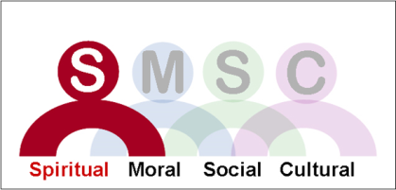
- sense of enjoyment and fascination in learning about themselves, others and the world around them
- use of imagination and creativity in their learning
- willingness to reflect on their experiences

Moral development

Enabling pupils to build a framework of moral values, aligned with the law of the land, which regulates their personal behaviour. It is also about gaining an understanding of the range of views and the reasons for the range. It is also about developing an opinion about the different views.

The moral development of students is shown by their:

- ability to recognise the difference between right and wrong, readily apply this understanding in their own lives and, in so doing, respect the civil and criminal law of England
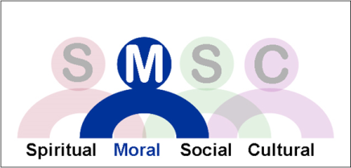
- understanding of the consequences of their behaviour and actions
- interest in investigating and offering reasoned views about moral and ethical issues, and being able to understand and appreciate the viewpoints of others on these issues

Social development

Young people working effectively with each other and the development of the inter-personal skills necessary for successful relationships. It is about functioning effectively in a multi-racial, multi-cultural society and making a positive contribution to the school community and wider society.

The social development of students is shown by their:
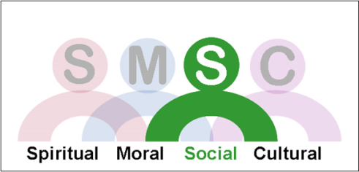
- use of a range of social skills in different contexts, including working and socialising with pupils from different religious, ethnic and socio-economic backgrounds
- willingness to participate in a variety of communities and social settings, including by volunteering, cooperating well with others and being able to resolve conflicts effectively
- acceptance and engagement with the fundamental British values of democracy, the rule of law, individual liberty and mutual respect and tolerance of those with different faiths and beliefs; the pupils develop and demonstrate skills and attitudes that will allow them to participate fully in and contribute positively to life in modern Britain

Cultural development

Helping pupils to develop an understanding of their own culture and other cultures in their town, region and in the country as a whole. Promoting pupils’ cultural development is intimately linked with schools’ attempts to value cultural diversity and prevent racism.

The cultural development of pupils is shown by their:

- understanding and appreciation of the wide range of cultural influences that have shaped their own heritage and that of others
- understanding and appreciation of the range of different cultures within school and further afield as an essential element of their preparation for life in modern Britain
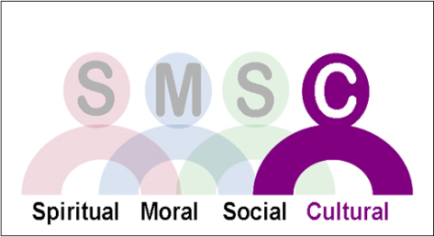
- knowledge of Britain's democratic parliamentary system and its central role in shaping our history and values, and in continuing to develop Britain
- willingness to participate in and respond positively to artistic, sporting and cultural opportunities

How we promote opportunities for SMSC

SMSC is omnipresent in our Pride curriculum, which is taught in fortnightly Barnwell Pride lessons in key stage 3 &4, and is a way of making the curriculum relevant to the experiences, past, present and future of the students. It provides depth and integrity to what we do and humanises the curriculum.

As well as Pride Curriculum that is taught in Barnwell Pride lessons, we have a plethora of other avenues that all explore the SMSC strands.

Ethics lessons cover our Religious Education content and as such, cover many areas of the SMSC framework. Students have one lesson of Ethics per week.

All subjects can and should contribute to this SMSC awareness and identify in plans where this will be done and possible areas where they may arise naturally. Because we have a shared understanding of SMSC, teachers are better able to identify both planned and spontaneous opportunities across the whole curriculum.

Pastoral curriculums which are worked through in form time focus on different areas and are further developed in related weekly college and/or year group assemblies.

Whole-school promotion of SMSC

School Ethos

The promotion of students' spiritual, moral, social and cultural development provides the why (as opposed to the ‘what’ and ‘how’) of education. It is an essential ingredient of school success and every adult in school has a major role to play in promoting this. Values are communicated both implicitly and explicitly. The way we respond to students, the relationships we build with them, the examples we set, all express the values we live by and can be shared and explored. It is expected that in all our dealings with students, we all strive to adhere to and promote theses values.

School Curriculum

SMSC can be evidenced in Barnwell Pride lessons and every subject area contributes to the SMSC development of students and will highlight in medium-term planning (Schemes of Work) opportunities for SMSC. These will not be set in stone as sometimes these opportunities might not be appropriate, or other opportunities might arise. SMSC is organic and grows through our responses to the opportunities provided by our subjects, our interests and above all by the experiences and interests of the students. Our clear understanding of the role of SMSC in education and our commitment to promote it will be the key to our success.

Teaching & Learning

Teachers will inspire students through the enthusiasm for and modelling of learning. Teachers will use creative strategies and challenging questions to engage students in their learning and relate it to their own experiences.

Extra-curricular activities and community links

Personal development is enriched through a wide range of extra-curricular activities, which provide opportunities for SMSC and for inspiring students to broaden their experience and horizons. These make significant contributions to the ethos and spirit of the school. Barnwell offers a huge amount of educational opportunities outside of the classroom. There is an extensive range of local, regional, national and international trips and visits on offer. These are all very popular and allow students and staff to experience the world away from school.

We work in partnership with parents and the wider community to make sure that we give our students the best possible environment in which to grow, flourish and learn.

*Note – Many of the normal opportunities to promote SMSC in school have been temporarily stopped due to Covid regulations. We have had to remove form times (due to initiating a staggered timetable) and extra-curricular clubs for the majority of the year, and we are only just beginning to open extra-curricular opportunities at the time of this update.
Weekly assemblies have now returned, but have been virtual in nature, so we are seeing additional opportunities to incorporate SMSC strands back into everyday life of the school.

