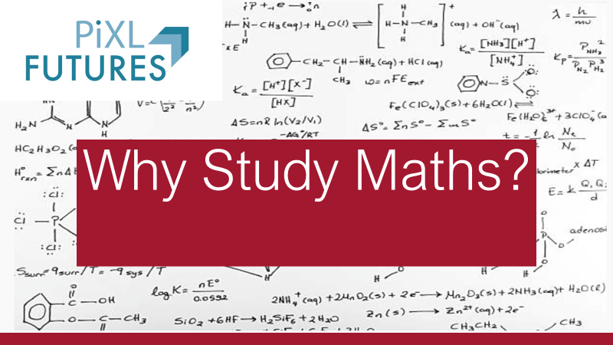
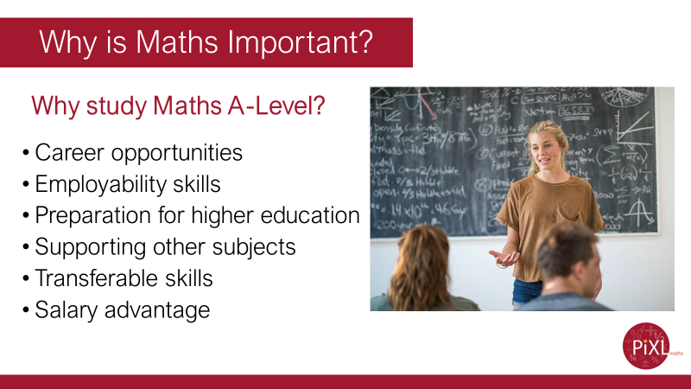
Get pupils to think about what opportunities Maths A-Level presents.
Career opportunities - People who have studied mathematics are in the fortunate position of having an excellent choice of career.
Employability skills - employers highly value mathematics qualifications because students become better at thinking logically and analytically.
Preparation for higher education - Anyone applying to study a degree in a STEM subject should consider taking Further Mathematics to at least AS level as the additional content helps ensure a successful progression to university.
Supporting other subjects - mathematical skills you learn in A level Mathematics are of great benefit in other A level subjects such as physics, chemistry, biology, computing, geography, psychology, economics and business studies.
Transferable skills - The aspects of a student which are developed during a Mathematics course are easily extrapolated to other situations and areas. For example, rational and logical thought is something which is required in many areas, whether it is in a moral or career capacity.
Salary advantage - graduates earn on average a significant amount higher than the average starting salary.
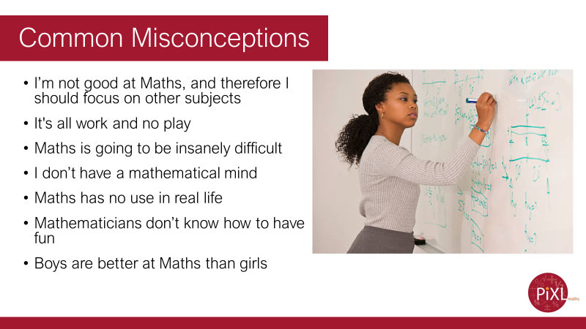
Organise yourself and you will have a good amount of free time throughout the week to pursue your own interests.
You will have to work and revise, so regardless of how easy or difficult you found your GCSEs, just go into your A Levels open-minded and ready to work.
Discuss Fixed and growth Mindset.
Fixed Mindset: reluctant to take on challenges; prefer to stay in your comfort zone; fearful of making mistakes; think it is important to 'look smart' in front of others; believe that talents and abilities are set in stone, you either have them or you don’t.
Growth Mindset: believe that talents can be developed; view mistakes as an opportunity to develop; are resilient; believe that effort creates success; think about how they learn.
https://www.youtube.com/watch?v=GVG4wgCqeEQ
Click the picture to play the video. We suggest you embed this to avoid ads and pop up. We are not able to do this due to our copyright restrictions.
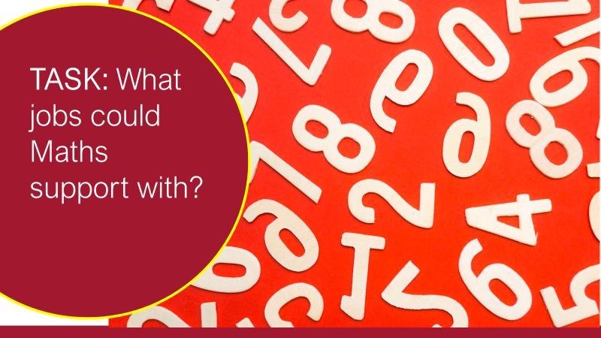
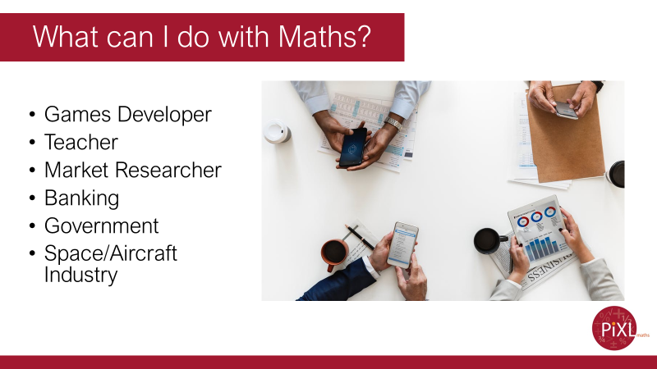
Ask pupils to discuss how they think their character has developed throughout their school life. Have they become analytical in their thinking? Are they logical in their arguments? Etc.
Emphasise through gaining these skills they develop resilience and are able to think creatively and strategically in every situation.
Ask pupils to discuss how they think their character has developed throughout their school life. Have they become analytical in their thinking? Are they logical in their arguments? Etc.
Emphasise through gaining these skills they develop resilience and are able to think creatively and strategically in every situation.
Ask pupils to discuss how they think their character has developed throughout their school life. Have they become analytical in their thinking? Are they logical in their arguments? etc
Emphasise through gaining these skills they develop resilience and are able to think creatively and strategically in every situation.
https://www.youtube.com/watch?v=ytVneQUA5-c
Get students to discuss what is going on with the colours in the numbers 1 to 20.
Show video at 3:50 to 9:12
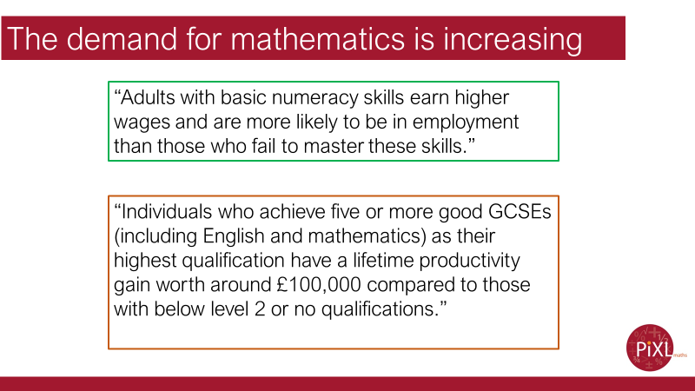
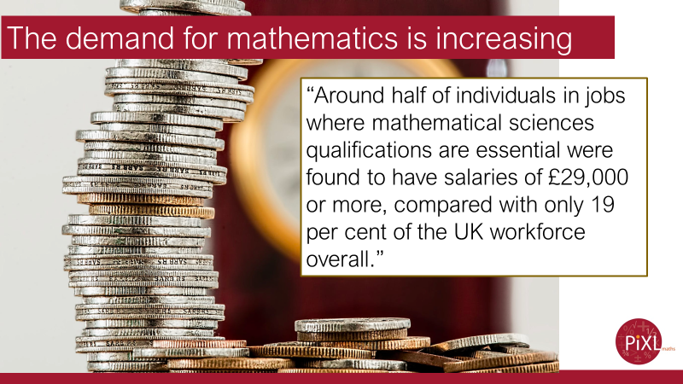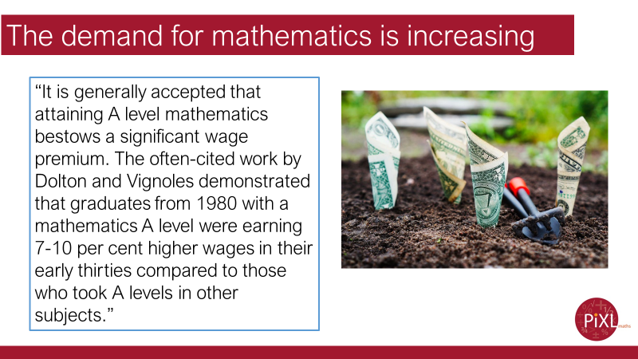
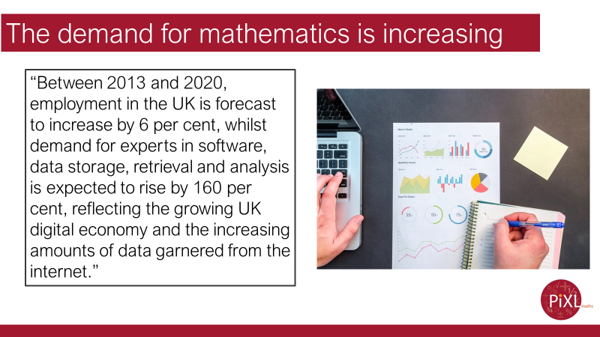
The website icould.com offers a range of videos from professionals in the industry talking about their careers. Follow this link to see the range of careers available to you, and listen to people who are actually working within those:
https://icould.com/explore/subject/maths
Alongside this, careermap.co.uk provide further information regarding careers:
https://careermap.co.uk

