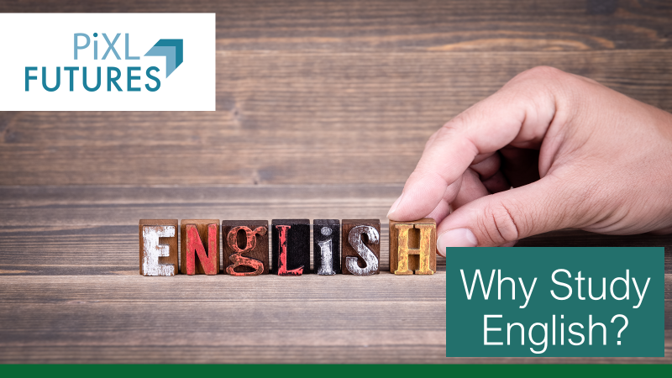
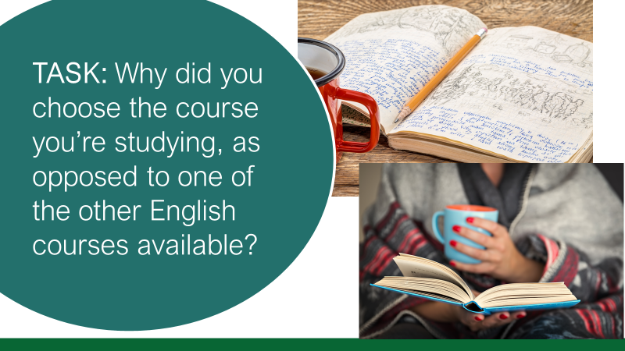
Depending on the subject, students will have different responses to this question – it will be useful for teachers to hear students’ reasoning and whether they have interest in taking this forward in future (in which case the session could focus slightly more on careers) or whether they are just taking it for now and they don’t intend to go onto higher education at all (in which case teachers will want to adapt discussions in this session to focus on the skills that the subject they are studying provides).
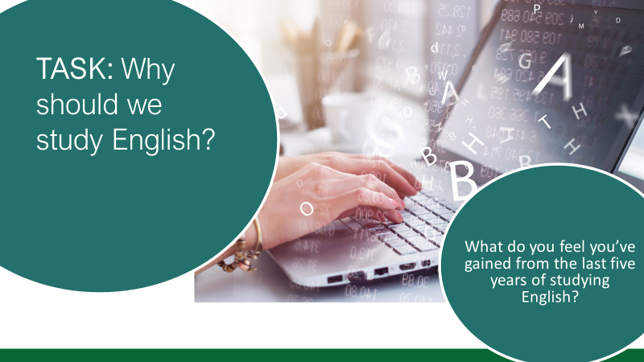
Pose question to students and collate ideas on the board. The fact that students will have selected to study the subject post-16 means that they should all be able to respond to this question with some ways in which English has been beneficial and/or interesting. Sharing these can be useful for students to see the diverse range of responses.
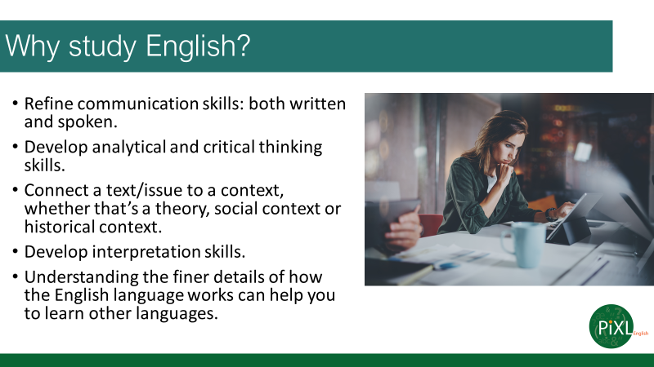
This is the same skill list that is in the PiXL Futures English Year 10 session. This will be a useful recap at the start of Year 12 for students to reflect on, now that they have spent two years studying the GCSE courses, in light of the question on the previous slide, and also for them to think how the specific subject they have chosen (lang/lit/lang and lit) may develop particular skills more than others and/or additional ones.
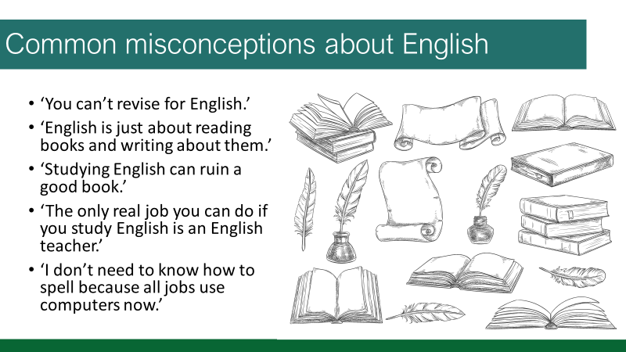
Teachers could ask students to raise hands for each one to see how many students would agree/disagree with the statements on the board.
The group could discuss each one or the teacher could ask individuals to feed back thoughts and ask why it may be true and why it may be false. Depending on the group, discussing why English can/cannot be revised could be an interesting discussion for example and provide staff with an opportunity to pose ideas or seek ideas from the group to dispel that misconception, if relevant.
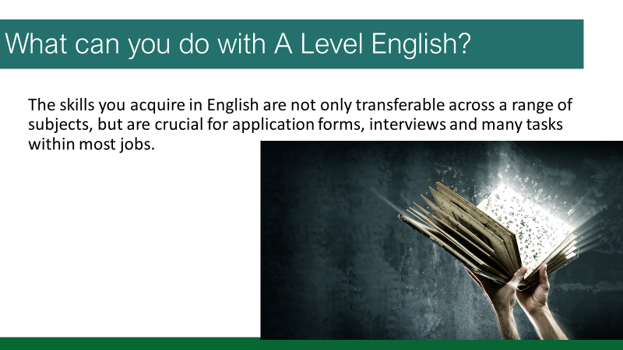
After addressing misconceptions, it would now be useful for students to consider what they can do with English after they leave school.
- What skills will it allow them to have? (recap from earlier)
- What jobs will English be useful for? (applying their awareness of the skills)
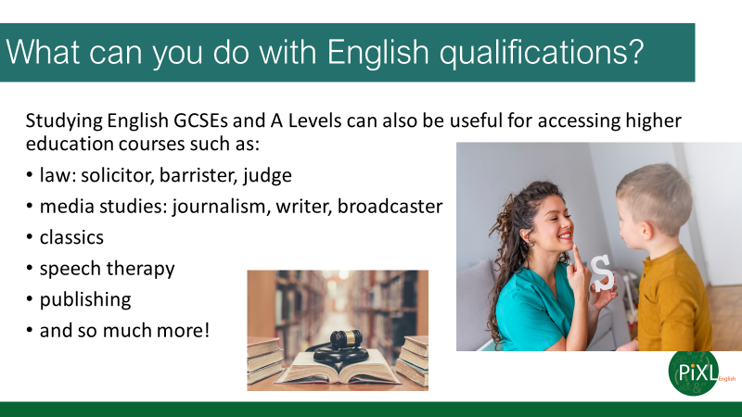
By pointing this out to students, they can see that studying English at GCSE and A Level doesn’t mean they’re confined to the study of ‘words’ or ‘books’. They can use this subject and the qualifications they receive to go into recruitment, marketing, research, media and so many other areas. Remind students that it is the transferable skills they develop in English that allows and facilitates this flexibility.
The discussion on slide 2 will help inform whether this needs to be a significant focus or whether you progress onto the next slide to springboard off discussions based on the next couple of slides.
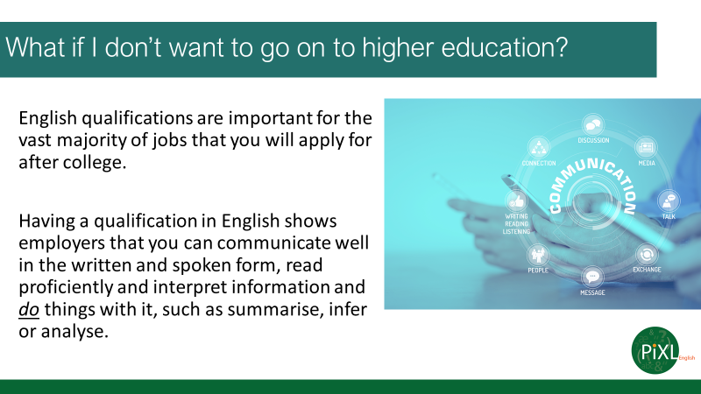
The discussion on slide 2 will help inform whether this needs to be a significant focus or whether you continue to springboard off discussions about careers from the previous slide and the jobs these may lead to, rather than ones they may apply for in the next year or two.
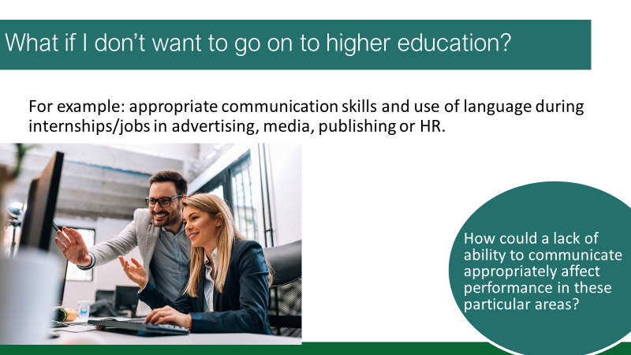
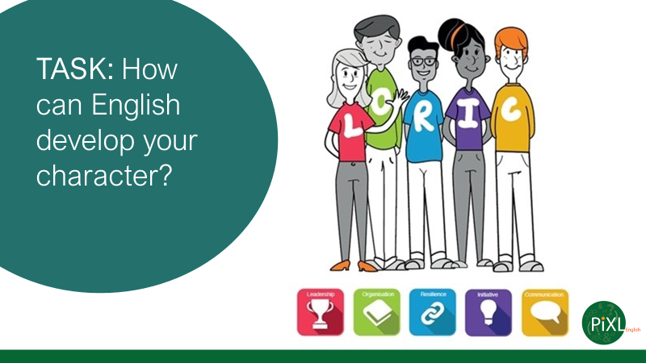
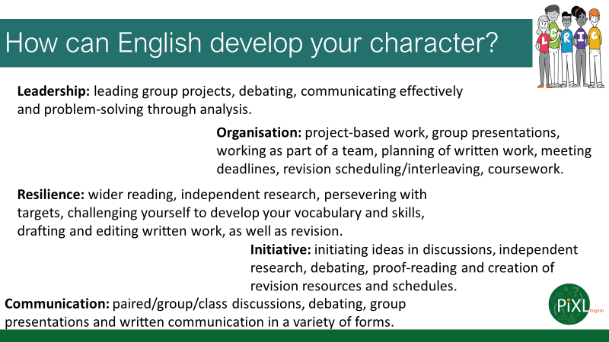
Link to The Edge.
Depending on the course, you may wish to remove coursework from the organisation section, as well as adding anything relevant to your specific qualification, board and specification.
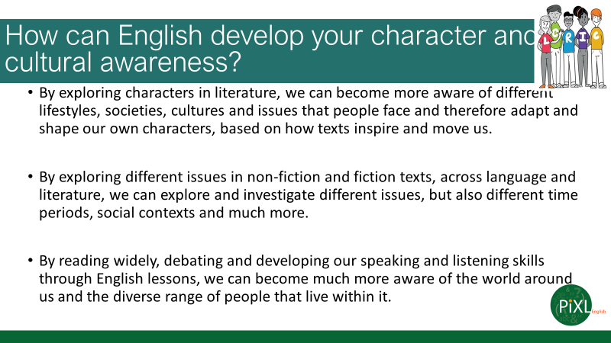
Again, this content is also on the Year 10 English PiXL Futures session, and it can act as a useful recap now that students are in Year 12 to consider how the GCSE study helped them develop their character and culture, before building on this to consider how the subject they have chosen for post-16 study may continue some of these more than others or introduce other areas they can think of.
Speech and Language Therapist
https://icould.com/stories/helen-w-2/
Assistant Planner:
https://icould.com/stories/michael-c/
Senior Features Writer:
https://icould.com/stories/rosie-m/
